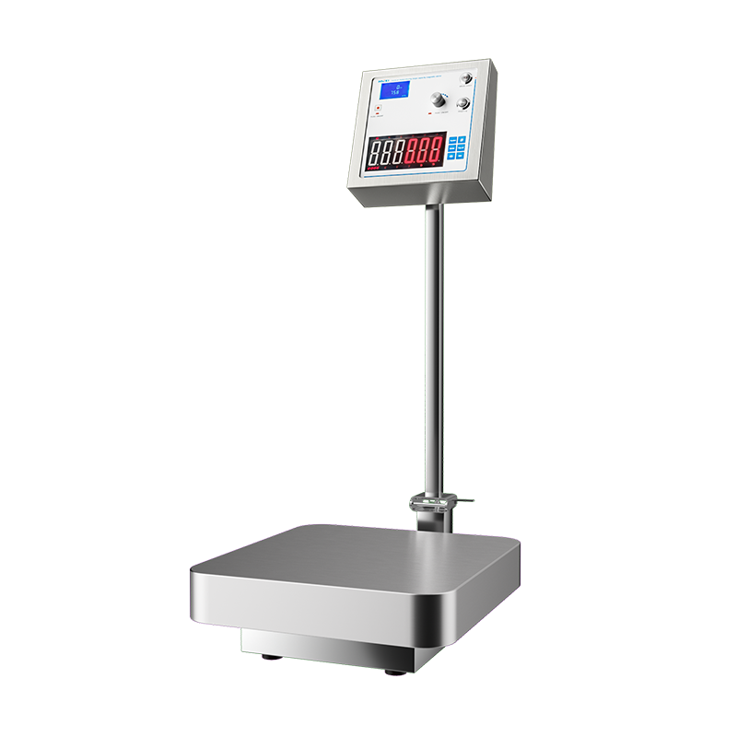

# **MS-CZ120 Large Capacity Weighting Magnetic Stirrer**

# **Shaker**

# HT-S330 **Rotary Shaker**

**Application：**

MS-CZ120 magnetic stirrers utilize the magnetic field coupling principle to transfer the stirring power to the movable stirrer at the bottom of the dosage drum, which mixes the different liquids in the drum as it rotates. Since the magnetic stirrer does not have any mechanical connection in the power, there is no risk of contamination, which meets the pharmaceutical industry's stringent requirements for hygiene. Equivalent to the ordinary magnetic stirrer this product is also equipped with an electronic scale on the device, in use can be proportional to the liquid mixing, making the device in the operation more convenient. This mixer is suitable for (non-viscous) drug liquids, beverage ingredients and filling when stirring and mixing, widely used in cell culture of biological products, laboratories and other pharmaceutical industries.

**Main Features：**

* Integration of weighing and magnetic stirring;
* The casing is made of 304 stainless steel;
* Brushless DC motor with the latest computerized closed-loop control, high torque and precise setting;
* Adopting excellent sensors, with accurate and repeatable measurement, wide measurement range and multiple ranges for selection;
* Using a variety of specifications of the mixing barrel, so the volume is small, light weight, no leakage, low wear and tear, no dead space, easy to clean, sterilization.

**Technical Parameters：**

|  |  |
| --- | --- |
| Model | MS-CZ120 |
| Item No. | 1002056001 |
| Power supply | AC220V±10% |
| Stirring Time | 1-9999min |
| Stirring Speed | 20-1000r/min |
| Maximum Resolution | 0.01kg |
| Maximum weighing capacity | 500kg |
| Platform Size | 450*450mm |
| Maximum mixing capacity | 120L（H2O） |
| Standard stirrer | 16×100mm |
| Weighing Accuracy | 0.02kg |
| Instrument size (L*W*H) | 450*620*1000mm |
| Packing size (L*W*H) | 830*475*280mm |